Mental Health Risk Prediction

Developed by:

Gaurav Sharma (BE/25052/16)

INTRODUCTION

DNN Classifier

A deep neural network is an artificial neural network which has an input layer, an output layer and at least one hidden layer. Deep neural networks use mathematical modeling to process data and predict outputs. The model used in the discussed problem uses 3 hidden layers of 10 neurons each and takes as parameters, the feature columns, hidden layers and Optimizer. The Optimizer used is Adagrad Optimizer with learning rate 0.1 and regularization of 0.005. The model is trained over 500 steps, and the data is divided into batches of batch size 500.

AIM

To increase mental health awareness in working individuals so as to ensure early detection and prevention of mental health issues.

OBJECTIVE

This project applies Deep Learning to predict the risk of any mental health disorder based on certain characteristics such as age and family history.

PROBLEM STATEMENT

To predict the risk of a Mental Health Disorder in working individuals based on a survey dataset available at Kaggle.

TECHNOLOGIES USED

DNNClassifier by Tensorflow

DNNClassifier is a pre-built model available in Google’s Tensorflow library. This model is generally used to perform classification.

Flask Micro-web Framework

Flask is a micro-web framework written in python. It is helpful in deploying machine learning models into web applications.

HTML & CSS Frontend

HTML & CSS are used to make the front end of the web application.

Model Used

tensorflow.estimator.DNNClassifier

The DNNClassifier calls tf.estimator.DNNClassifier from the tensorflow python API. This command builds a multilayer feedforward neural network that is trained with a set of labelled data in order to perform classification on similar unlabelled data.

IMPLEMENTATION

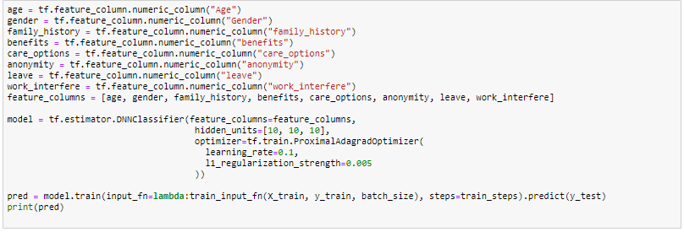

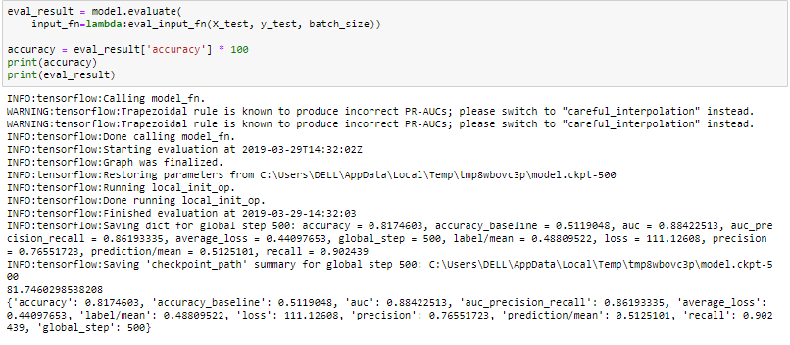

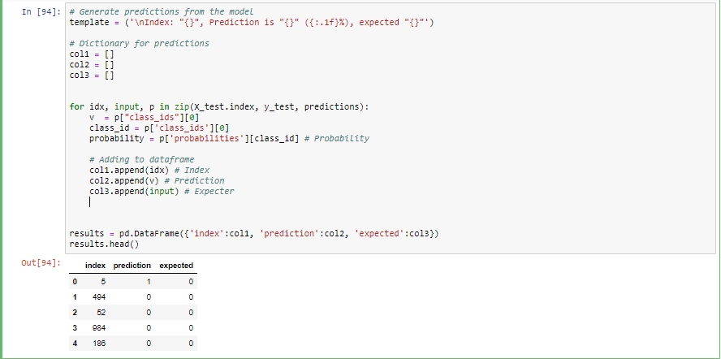

Input Features

Age?

Gender?

If you have a mental health condition do you feel that it interfaces with your work?

How easy is it for you to take medical leave for a mental health condition?

Is your anonymity protected if you choose to take advantage of mental health or substance abuse treatment resources?

Do you the options for mental health care your employer provides?

Does your employer provides mental health benefits?

Do you have a family history of mental illness?

EXECUTION

This model predicts whether an user may or may not have a mental health risk with probability of the given prediction being true.

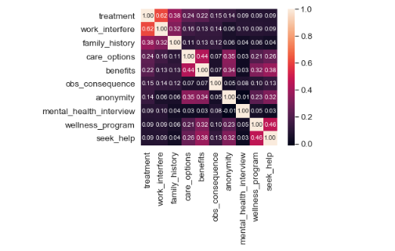

Results Obtained :

An accuracy of 81.74% is obtained by the model, the model works fairly well in predicting whether or not an user has a mental health risk.

Data Visualization

Visualizing and understanding the data and dropping unnecessary features.

Data Preprocessing

Preprocessing the data to convert all features into numeric values and normalizing Age. Initializing Model We initialize the model with three hidden layers of 10 units each.

Training Training our model on preprocessed data so as to make predictions.

Evaluating Accuracy We finally evaluate the accuracy which comes out to be 81.74% and make prediction on testing data.

CONCLUSION

In this report, we looked at the DNNClassifier by the TensorFlow.We have implemented it for the MentalHealthPrediction to predict the Mental Health of a person in corporate sectors.